FALL 2013- FINAL REPORT
EML 4551C
Dr. Amin

Team 4: Alternative material for compressor casing in turbocharger

Group Members
Alexander Mankin- Team Webmaster
Harrison McLarty- Project Leader
Abiodun Oluwalowo
Ralph Scott
Faculty Adviser
Dr. Peter Kalu
Sponsor
Cummins, Inc. – Roger England
Director, Advanced Manufacturing Technology and Materials Engineering
TABLE OF CONTENTS
1. Abstract/ Executive Summary 1
2. Project Overview 1
2.1 Customer Requirement 1
2.2. Project Scope 1
2.2.1 Problem Statement: 1
2.2.2 Justification/Background: 1
2.3 Goals 2
2.4 Objectives: 2
2.4 Constraints 3
3. Design and Analysis 4
4. Risk and reliability Assessment 10
5. Detailed design and design for Manufacturing 11
6. Procurement 11
7. Communication 11
8. Conclusion 12
9. Environmental and safety issues and ethics 12
10. Future plans for prototype and others 13
11. Gantt chart, resources, and budget 14
11.1 Gantt Chart 14
11.2 Resources 15
11.3 Budget 16
12. References 16
13. Appendix 17

1. Abstract/ Executive Summary
The main goal of this project is to provide a cost efficient alternate material to be used on the compressor casing in Cummins B series turbocharger. Currently the company uses cast aluminum 356 to manufacture and produce their compressor casings. Research was completed on materials, specifically polymers, which could offer long term cost reductions in manufacturing and production costs, but at the same time be reliable and safe to use under the operating conditions in a turbocharger. Operating temperatures and pressures were obtained from the sponsor, as well some other stresses and loads the compressor experiences under operation, in order to find materials which could operate under these conditions. However, these materials must also possess adequate strength and ductility to withstand a burst event in which the compressor blades break off from the main shaft and impact into the casing. Due to all of these considerations the search for adequate materials has been a challenge. Several candidates have been found which seem to satisfy the maximum operational conditions found within the compressor, and possess an adequate strength and ductility. After preliminary analysis these materials were found to be EXTEM-XH, PEEK, TECATOR T15013, and TECAPEEK ST. In order to select the most effective material to construct a prototype, a weighted decision matrix was utilized composed of several components related to strength, ductility, machinability, dimensional stability, and functional testing capability. Finite element analysis was also used to ensure that none of the considered materials would deform under the specified operating conditions associated with a compressor in a turbocharger. After the analysis was completed it was found that PEEK was the most efficient and effective material to be used in machining and constructing a compressor casing for a prototype.

2. Project Overview

2.1 Customer Requirement
Cummins has presented the team with the challenge of finding a cheaper and more cost effective material to replace the current aluminum casting solution, which is used to fabricate compressor casings in their B series turbochargers.

2.2. Project Scope

2.2.1 Problem Statement:
The project sponsor has conveyed the potential benefits for Cummins in selecting a cheaper and more cost effective material to use in fabricating their compressor casing. However, this alternate material must satisfy the current benchmarks and design parameters currently in place by Cummins in producing the compressor casings. Also, it must match or exceed the aluminum casings’ temperature and strength tolerances.

2.2.2 Justification/Background:
Turbochargers present many advantages in increasing the efficiency of internal combustion engines. The turbocharger essentially diverts heat from the exhaust side of the combustion chamber, which would otherwise be emitted to the atmosphere as waste heat. These hot gases then spin a turbine coupled on a shaft with a compressor. The compressor then is able to draw in atmospheric air which increases the air’s pressure while decreasing its velocity through a diffuser. After passing through the compressor the air’s temperature is considerably higher and is passed through an intercooler to increase its density before it is forced into the combustion chamber. With the increased amount of air there is a reduction in the amount of fuel required to power the vehicle, which increases its efficiency.¹ This particular project is concerned with the intake side of the turbocharger where the compressor is located. Our project sponsor has conveyed a desire to replace the aluminum alloy used to fabricate their compressor casings. Materials which are cheaper to manufacture and process, with the same properties and tolerances as those currently used in products, present huge advantages for companies such as Cummins. The revenue saved from using these more cost efficient materials and manufacturing processes can be used to increase the quantity of products produced. This also allows the company an opportunity to expand its customer base while maintaining the same quality and reliability in its products. Cummins would like to use this approach in its B series turbochargers. The company wants to find a cheaper material and manufacturing process capable of replacing the aluminum casting solution around the compressors in their turbochargers.

2.3 Goals
The goals that we feel should be achieved are the following. First, research new materials that could prove to be a practical alternative to the current aluminum alloy used in the turbo charger compressor casing. Secondly, test prototypes made of the alternative material and compare the results to the aluminum compressor casings, and see if they meet the current standard. Finally see if the materials prove to not only be as strong and reliable as aluminum, but more cost effective and cheaper to manufacture.

2.4 Objectives:
- Study the temperatures, pressures, and stresses a compressor experiences under extreme operating conditions
- Find materials, which can possibly withstand the variables and effects listed above , and are cheaper than the aluminum alloy material currently used
- Use cost analysis to discover how much revenue could approximately be gained by selecting some of the alternate materials under consideration
- Use simulations and CAD design to study these materials and their ability to withstand the stresses under operating conditions possibly aided by Finite Element Analysis.
- Use Failure Effect Mode Analysis during the design and simulation phase to narrow the selection process for the materials under consideration.
- Fabricate the compressor casing with the final selected material of choice which offers a fair balance between cost efficiency and emulating the material properties of the original aluminum alloy. Then commence testing with the prototype casing using a turbocharger provided by our sponsor.

2.4 Constraints
Cost:
Our main constraint for this project is the cost of the compressor casing itself. The sponsor made it clear that his concern was the overall cost of materials and manufacturing of this product while also keeping it as functional as the previously designed part.
Design:
The design of the compressor itself should be the same as the previous model; only slight changes can be made. It is already a proven design and there are many special constraints due to the small amount of open space in engine bays.
Weight:
Weight is not a main constraint in this project but if it is also possible to do so, a lighter weight material than the current one in use is desired.

Time and Budget:
Our total budget allotted for this project is $2000. The preliminary design and ordering of parts or materials should be completed by the end of fall of 2013.
Fig.1 Image of compressor casing taken from CAD assembly provided by project sponsor

3. Design and Analysis
Functional Analysis
Here is a Functional Analysis diagram of how a turbo charger works.
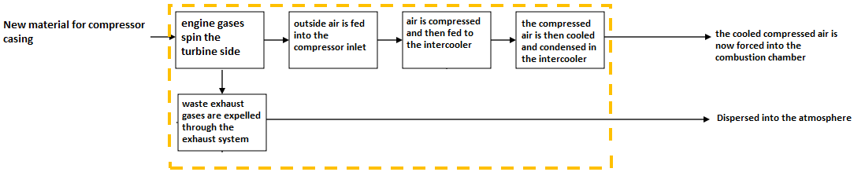
Design Concepts
Our design Concepts would be the multiple alternate materials that we have found that have proven to meet the demands of the turbo charger compressor casing environment given to us by Cummins. Through comparison of the current aluminum 356’s material characteristics, and with the help of Cummins, who helped verify our material choices, we have been able to successfully eliminate the materials deemed unsuitable for our application. With this knowledge we can now make a more informed and reliable material selection for the turbo charger compressor casing.
The first material we had selected is a polymer called Extem XH. Our research into this material showed that based on material properties alone this material seemed capable of being a candidate to replace aluminum 356. The key properties that make this a viable material are the following. To begin, it has a tensile strength of 120 MPa, comparing that with aluminum 356, which has a tensile strength of 124 MPa, shows that these two materials have similar tensile strengths. One of the most important characteristics it displays is its ability to operate continuously at 230°C, which is right at our required 230°C mark. Also this material displays good ductile characteristics, with an elongation at break of 7%. This will help with the materials ability to withstand impacts without fragmenting. Some other advantages of this material are its ability to perform from temperatures below zero all the way up to 230°C, as well as good process ability and chemical resistance. Some of the weaknesses would be that, at any temperature above 275°C the material will start to soften, and currently the cost of the material is unknown. Which if it his higher than aluminum 356, it becomes no longer viable as a realistic replacement for aluminum 356. After sending this material to Cummins for further review, they too deemed that this material would be capable of meeting the demands of the turbo charger compressor casing.
The second material we had selected was Fluorosint 500. Initially through our own research and study of the materials physical properties, we had felt that this could have been a viable alternative material. However, after sending this material to be evaluated by Cummins, we learned that this material would not have proven suitable. This was mainly due to the fact that, a large enough block of the material could not be purchased in order to have a prototype properly machined. Also it would not have been able to withstand the loads associated with the turbocharger compressor casing
The third material we chose was PEEK (polyetheretherketone) unfilled. Like Extem XH this material also proved promising during our research of the material. It has a continuous operating temperature of 260°C, which is above our maximum temperature requirement. It also has a very high deflection temperature at 264 PSI of 316°C. this shows that not only can the material with stand the temperature generated in and around the compressor casing, but can also with stand well above the pressure requirements of 28 PSI. Its advantages include, excellent flexural, and impact characteristics, as well as exceptional chemical resistance and wear and abrasion resistance. In addition, this material possesses excellent ductility with an elongation at break of approximately 20%. Also, similar to Extem XH, Cummins also approved this material to be an acceptable possible replacement for aluminum 356.
The fourth material we had selected was Rulon 945. And just as in the case of Fluorosint 500 this material was deemed unacceptable as an alternate material for the same reasons. Both lack of appropriate size and loading capabilities.
Of the new materials we had researched and selected only TECAPEEK ST and TECATOR T 15013 where deemed suitable by Cummins for use in the turbocharger compressor casing. Both of these materials had 260°C continuous melting temperatures, and both could be easily machined. They are also both very strong, with TECAPEEK ST having a yield strength of 130.3 MPa and TECTOR T 15013 having a yield strength of 144.8 MPa. But they also remain ductile with an 11% elongation at break for TECAPEEK ST and a 15% for TECATOR T 15013.
The new materials that we researched that didn’t pass Cummins approval were the following. First, the material TECASINT 2000, is not applicable for our use do to the fact that it cannot be molded due to the absence of a softening point hence processed via sintering. It is also prone to hydrolysis upon contact with alkaline fluid of high pH. The next two, TECAPEI & FORTUS PPSF, cannot withstand the peak temperature of 230°C.
As far as manufacturing considerations, whereas the aluminum compressor casing was cast, compressor casings made from these polymer materials will most likely have to be injected molded. At this point in our research we have yet to conclude how much this will cost compared to that of casting aluminum. For prototypes however, a solid block of these materials would have to be ordered and then given to a machinist who would then machine a compressor casing from the block of material.
Evaluation of designs
The selected materials were evaluated based on their material properties. These properties were then compared to the properties of the current material, aluminum 356, as well as the design requirements given to us by our sponsor. With the main requirement being the 230°C maximum heat requirement. So after looking at these requirements and with the help of our sponsor Cummins, we were able to eliminate any materials that did not stand up to the requirements, and select ones that did.
Finite Element Analysis
Previously, a preliminary analysis was done on a 2D cross section to simulate operating conditions to determine if there was any deformation during that time. This previous analysis did present some useful information and can be found in the appendix; however, a more in depth model is needed to accurately represent the physical system of the turbocharger. Unfortunately we have had some issues importing complex geometry, which caused the analysis to be performed on a simple three dimensional cylinder. One main point of interest was to see if there was a large magnitude of difference in the stress distribution between the two and three dimensional models.
The simulation was done on a two dimensional model which neglected any stress in the axial direction. The current three dimensional simulation was modeled with constrained ends and free ends to see if it could replicate the two dimensional simulation accurately and to try to find any differences between them. It was found that while the magnitude of difference in the stress distribution was not largely different of the model which assumed a constrained and free end, the constrained ended model would be the most accurate when describing the physical system. Below are the different stress and strain results which were found while performing this analysis on the cast aluminum A356.
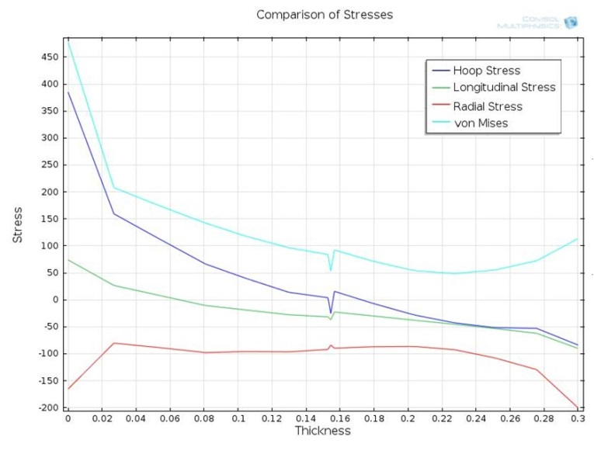
Fig 2. Comparison of Different Stresses
Table 1. COMSOL Results
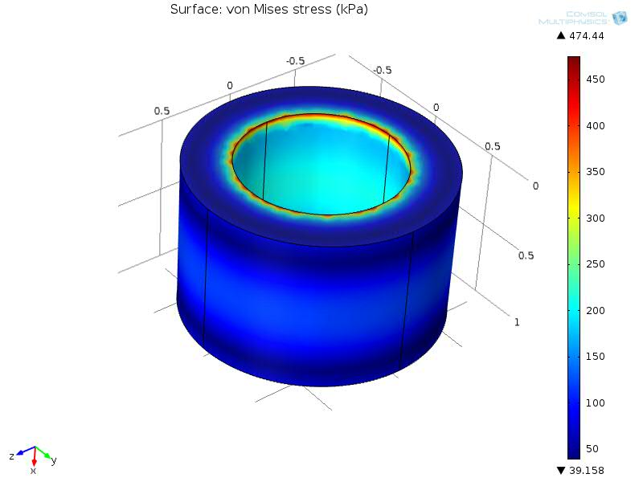  Figure 3. von Mises Stress | 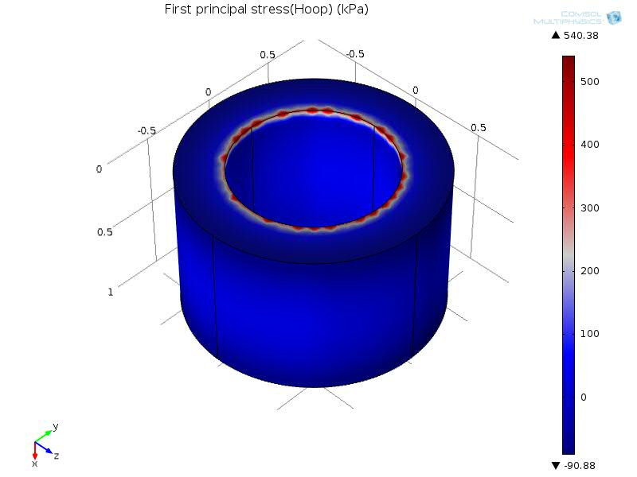  Figure 4. Hoop Stress
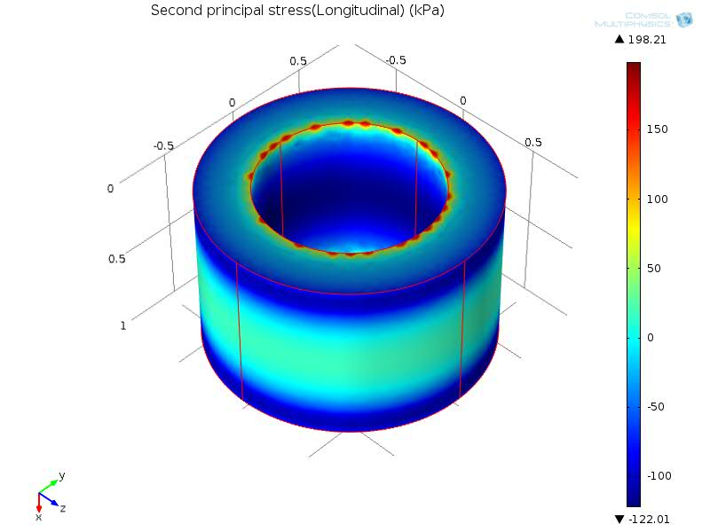  Figure 5. Longitudinal Stress | 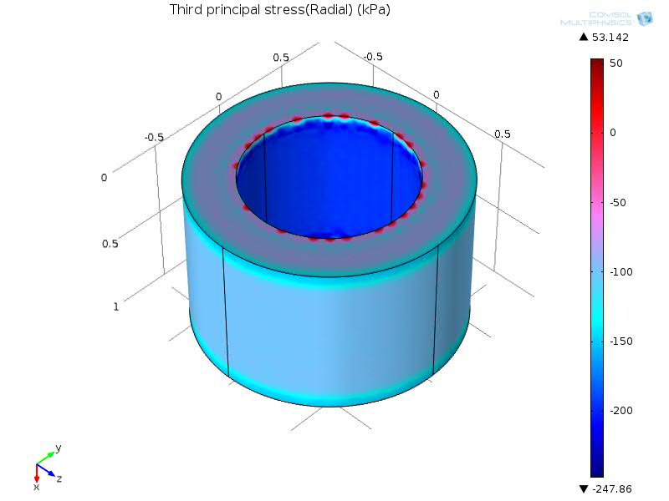  Figure 6. Radial Stress

By performing our analysis we found that the maximum stress occurred in the hoop or circumferential direction with it being around 380.0 kPa. These stresses were equal at all heights of the cylinder. The longitudinal stress experienced was approximately 75.0 kPa. The maximum stress in the radial direction was equal to around -170.0 kPa. Due to the fact that our materials possesses significantly higher yield stresses than those found in the analysis, our alternate material most likely will not fail during the operation of the turbocharger. The graphs below show the strain which the base material experiences during its maximum operating conditions, which can be used to further determine whether our material is suitable for its proposed application.

Table 2. COMSOL Results
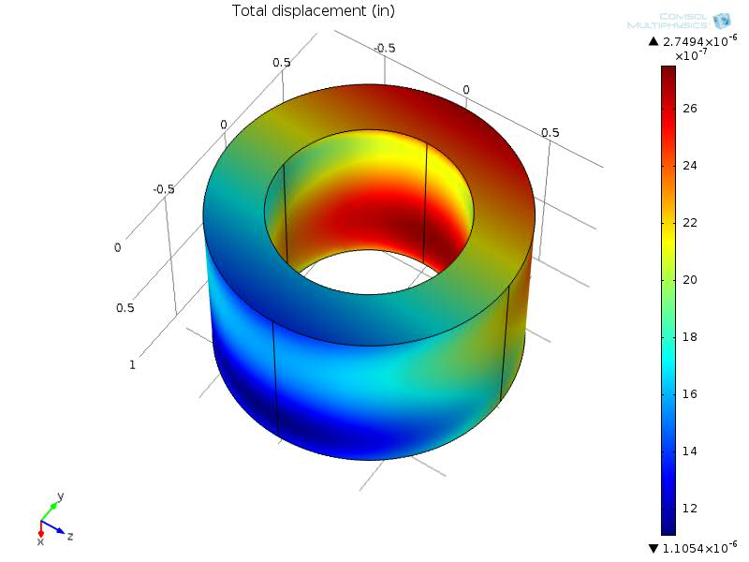  Figure 7. Total Displacement | 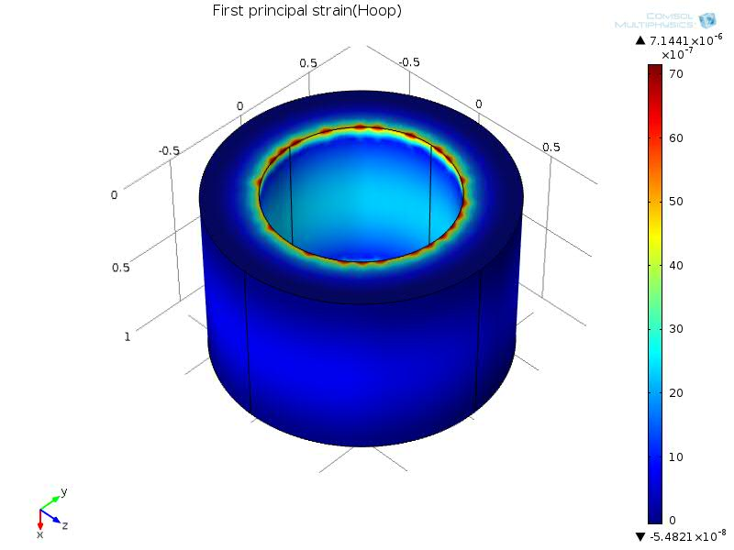  Figure 8. Hoop Strain
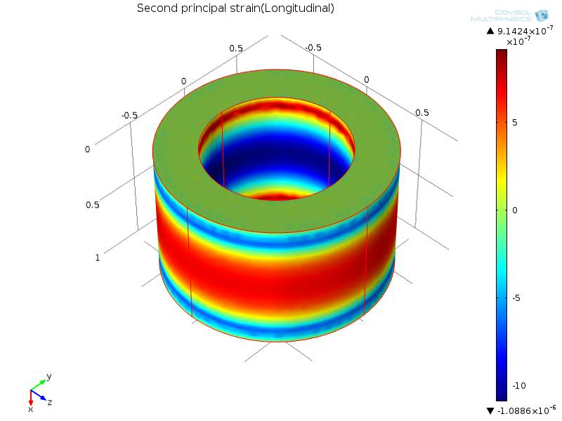  Figure 9. Longitudinal Strain | 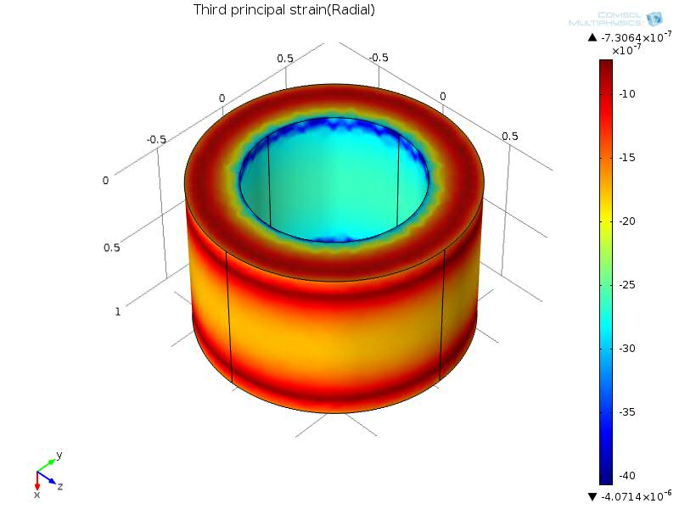  Figure 10. Radial Strain

These plots show that the maximum amount of strain experienced is around ${10}^{-6}$. These are very low numbers for strain which means almost no deformation will occur in the casing with the base material. This also can be said for our chosen materials due to the high yield strengths as mentioned previously. It is also important to mention that our findings were not the exact values found when we performed the previous two dimensional analysis, but they were still very similar. When more complex simulations are performed these simulations will be compared in order to determine its validity.

Weighted decision matrix
In order to select the most efficient material to machine a prototype, for an alternate material based compressor casing, a weighted decision matrix was utilized. The weighted decision matrix was used to compare the four potential material candidates Extem XH, PEEK, TECAPEEK ST, and TECATOR T15013, and determine which of these materials would be most suitable for fabricating a prototype. The matrix was based on several important parameters for analysis. These parameters were the yield strength, % elongation @ break, maximum continuous operational temperature, water absorption rate (dimensional stability), and functional testing capability. The parameters were selected to provide a material which had the best combination of strength, ductility, maximum continuous operational temperature, and dimensional stability. The decision matrix is shown below in Fig. 3.
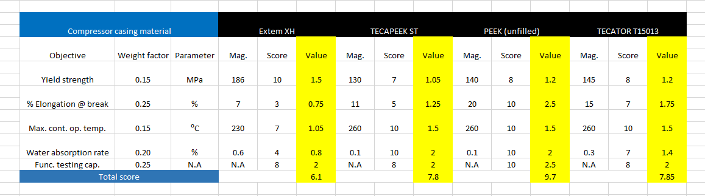
Fig.3 Weighted decision matrix used in selecting the most effective material for machining a prototype.
The weighting factors in the decision matrix were selected to yield a material which would contain a burst event most effectively. In order to contain a burst event, the material used to fabricate the compressor casing must possess an excellent balance of strength, ductility, and ability to continuously operate at high temperatures. The dimensional stability was given a relatively high weighting factor because it is extremely important that the material is able to maintain its geometric tolerances due to the small clearance between the inside surface of the casing and the tips of the impeller blades. The magnitudes of these material properties were applied to the matrix and a score was given to the material ranging from one to ten. A score of ten meant the material provided the best advantage with respect to its objective or parameter whereas a score of one would provide the least advantage. These scores were then multiplied by the weighting factor and the process was repeated for each parameter and material. The total scores were then analyzed by adding the values found for all of the parameters associated with each material. It was found that PEEK would be the most effective material to machine a compressor casing for testing and prototyping. PEEK possesses many advantageous characteristics such as heat resistance to temperatures beyond 230$℃$, resistance to deformation due to pressure, resistance to diesel engine fluids, dimensional stability, and an excellent combination of strength and ductility. A contact at Cummins confirmed this selection and stated that PEEK would the best material to construct a prototype compressor casing out of the materials researched.

4. Risk and reliability Assessment
There are several risks involved with selecting an alternate material for a device such as a compressor casing in a turbocharger. Due to the widespread use and importance of these devices it is crucial that any alternate material selected, even if cost efficient, be able to safely operate and withstand the physical conditions associated with a working turbocharger in an automobile. The catalyst of these potential risks can be attributed to the high operating temperatures and stresses associated with the compressor during operation.
The environments in which automobiles are used can also have a significant impact on the materials used to fabricate the compressor casing. Any alternate material considered must be able to operate under cyclic temperatures, for example from below zero freezing weather to normal operating conditions. Materials not suitable for these environments or operating conditions can fail catastrophically, leading to loss of property or life. Also, corrosive materials such as salt, dirt, engine coolant, oil, and other chemicals pose risks for the safe operation of a compressor casing. Therefore, the alternate material should be corrosion resistant to prevent failure and extend the lifetime of the product.
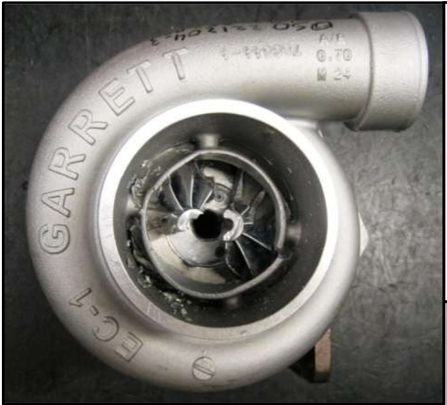
A major risk associated with selecting an alternate material for a compressor casing, in a turbocharger, is whether the material is able to successfully contain a burst event. A burst event occurs when the impeller blades, located in the compressor and turbine housing, experience failure due to the high centrifugal forces associated with the impeller wheel’s rotational velocity. These centrifugal forces can be high enough to eventually overcome the mechanical strength of the blades, which cause them to break off from the main shaft and impact into the casing. A view of such an event can be seen in Fig. 4. Burst events are caused by reduction of strength due to the high internal stresses associated with high temperatures and speeds, fatigue failure due to cyclic loading (stop and go motion of city bus), and foreign object damage (rock or piece of rubber impacting impeller blade). Burst events are rare occurrences, but there are serious safety concerns associated with them. For example, if either the compressor or turbine housing were unable to contain the debris associated with a burst event there is a possibly it could impact functioning equipment near the engine. One major concern would be if this debris were to strike a fuel line with the potential of a spark, flame, and explosion occurring endangering the lives of pedestrians within and near the automobile. A housing or casing must be able to contain any debris or shrapnel which could be produced from a burst event. A successful burst containment test for a certain material will not allow debris or broken material to pass through and exit the casing. It is for this reason that materials used to construct the casings around the compressor and turbine on the turbocharger must be strong, ductile, and be able to continuously operate at high temperatures. These factors directly influenced the layout of the weighted decision matrix to select the proper material to use for a prototype.
Fig.4 An example of a burst event showing the impeller blades broken and separated from the main shaft.

5. Detailed design and design for Manufacturing
Currently Cummins uses a casting solution to construct its compressor casing based on cast aluminum 356. For this project the team is considering more cost efficient materials and manufacturing processes. Based on these criteria the team will attempt to research and select a polymer material, which would cost less to manufacture and as a material. However, the design of the compressor casing must remain the same to ensure compatibility with their current turbochargers. Therefore no change in design will be considered for this project and all geometric tolerances will remain the same. One of the main issues for this project will be in researching, which manufacturing method would be most cost efficient for Cummins to employ in production of these compressor casings based on the selected alternate material. More research and information will be required in this area as this is a large portion of the project requirement. However, the team has begun preliminary insight into injection molding methods, 3-D printing, and perhaps an extrusion method. A detailed analysis of the cost of each process will be explored in the spring semester.

6. Procurement
A contact at Cummins is currently contacting Victrex, a PEEK resin manufacturer, and is attempting to obtain a large slab of the material based on the measured volume of the compressor casing. The volume of the compressor casing based on the team’s measurements was found to be 10.5 in x 5.25 in x 8.5 in. After obtaining the material, the contact will arrange for it to be machined into a compressor casing utilizing Cummins’ resources.

7. Communication
Communication was carried out through cell phone, email, and personal interaction between all team members. The team leader was responsible for coordinating meetings between the group and project sponsor. Emails were primarily used by the team leader to forward all documents and attachments sent by the project sponsor to the team leader. This ensured that all team members were kept up to date with expectations and information provided by the sponsor. A folder, located through the web service drop box, was also shared by the group, which allowed team members to upload their work contribution in to one location and update and improve their work if need be. This also allowed team members to view each other’s work and make suggestions or corrections. The team leader also sent text messages and informed members in person of future meetings held by the group.

8. Conclusion
From the research done at this time, the team has found that polymers most likely are the best candidates to replace the aluminum alloy. This material must be lower in cost than the current alloy, be able to withstand the operating conditions which the casing undergoes, and be manufactured more cost efficiently than the current casting solution. These materials were researched based on the baseline properties of cast aluminum 356 as well as the data which Cummins found during performance testing. Several materials were researched and considered in our search for an alternate material to replace aluminum 356. After further preliminary research was completed, the most effective candidates were found to be Extem- XH, Tecapeek ST, Tecator T15013, and PEEK. These materials offer their advantages as well as limitations. The majority of them have similar characteristics to the cast aluminum in terms of tensile yield strength and they are able to operate at temperatures greater than the minimum temperature allowable. To ensure that none of these materials would deform under the loads associated with the operation of the compressor, finite element analysis was utilized. The analysis was taken at a cross section found within the compressor casing’s tubing. The results showed that none of the materials experienced deformation, which would disrupt the operational integrity of the compressor and none having a distinct advantage related to the selection process. In order to choose the most effective material to machine a prototype, a weighted decision matrix was utilized based on yield strength, % elongation @ break, maximum continuous operational temperature, water absorption rate (dimensional stability), and functional testing capability. After comparing the results obtained from the matrix it was determined that PEEK would be the optimum choice in fabricating a compressor casing prototype for testing and experimentation. After consulting with our contact at Cummins, it was confirmed that from our list of possible material candidates PEEK was the best material to use in constructing a prototype. In addition our contact is attempting to obtain a 10.5 in x 5.25 in x 8.5 in volume block of PEEK from Victrex, a resin manufacturer of PEEK, for machining a prototype. Some major tasks which remain for the spring 2014 semester are estimating the manufacturing costs of these alternative material compressor casings based on an injection molding process, and analyzing the results of the prototype tests and experiments.

9. Environmental and safety issues and ethics
There are no known environmental risks or concerns associated with the material PEEK, which will be used to fabricate the compressor casing for prototype testing. The main safety issue associated with this project is ensuring the compressor casing composed of PEEK is able to successfully contain a burst event. Carrying out the burst test, to ensure the successful containment with the alternate material, is a procedure which requires safe practice. Cummins will arrange for these tests to be performed with safe, experienced, and reliable resources and personnel.

10. Future plans for prototype and others
One of the main goals of this project is to ensure that the alternate material chosen, PEEK, can withstand a burst event. A burst event occurs when the centrifugal forces acting upon the impeller wheels in the compressor overcome the mechanical strength of the wheel itself. In addition to being cost efficient, the compressor casing, based on PEEK material, must be able to contain any debris or shrapnel caused by a burst event. Therefore, the purpose of machining a prototype is to ensure that PEEK is able to safely contain a burst event. Cummins resources will be used to test the prototype and experimentally determine whether PEEK can contain a burst event.
In addition to this, a finite element analysis simulation will be done on more complex geometries and operating conditions such as burst containment and stresses caused by temperature fluctuations. These simulations are important to perform in order to verify the chosen material and provide Cummins with good baseline data which can be used if more alternative materials are pursued.

11. Gantt chart, resources, and budget

11.1 Gantt Chart

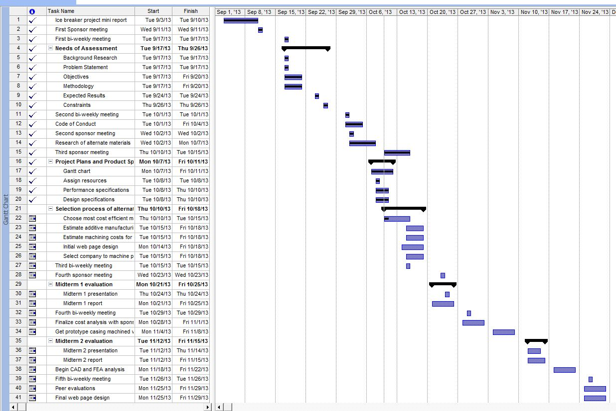
Fig. Gantt chart summarizing list of deliverables and tasks to be completed for Fall 2013 semester
Fig. Gantt chart continued for Fall 2013 semester

11.2 Resources
Team Leader – Harrison McLarty
The team leader will be responsible for managing communication between team members and with the project sponsor. Responsibilities also include assigning tasks to team members equally and providing expectations for these objectives. Tasks will include completing deliverables, project presentations, bi-weekly reports, and assuring a satisfactory solution for the demands of the sponsor. In addition the team leader will assist in researching and prototyping materials selected to replace the aluminum alloy currently in use by Cummins. This will include researching companies who can machine the compressor casing based on the alternate material chosen. Machining and labor costs for the compressor casing will also be obtained from the company ultimately chosen. Finally, the team leader will assist in finalizing the completion of deliverables and presentations.
Team members:
Web Design Master: Alexander Mankin
The web design master will be assigned with keeping the group website up to date and current. All deliverables, reports, and presentations will be uploaded to the website. The team will assist the web design master in selecting a template and format for the website, and will provide assistance if needed. In addition the web design master will use Finite Element Analysis to obtain theoretical data on the alternate material ultimately chosen.
Financial Advisor: Ralph Scott
The financial advisor will be responsible for organizing supplies needed for the project and their estimated cost. The advisor will update on the team on estimated costs of supplies and the current balance. The main responsibility of the financial advisor is to ensure the team possesses responsible spending practices and ensure that with the supplied funds the project is completed efficiently. The financial advisor will also assist the team leader in calculating the machining and labor costs associated with the prototype compressor casing.

Materials and Metallurgical Advisor: Abiodun Oluwalowo
The materials and metallurgical advisor will provide input and suggestions for the most effective materials to be used in replacing the aluminum alloy currently used by Cummins. All team members will complete research for alternate materials and the materials advisor can provide suggestions and comments on the quality and effectiveness of the materials selected.
All team members:
The project sponsor has expressed a desire for the team to calculate the additive manufacturing costs for the material chosen, and an annual cost estimate to fabricate these casings based on the alternate material. This will provide the sponsor with a comparison between the current production costs and the proposed costs associated with the alternate material. It will be the group’s responsibility to estimate these costs collectively. Also, all group members will present their findings for an alternate material and the final material chosen will be the one which is most cost efficient based on an estimate of the material and its additives. However, the material must closely match the material properties of the original aluminum alloy, cast aluminum 356, and be able to withstand the operating conditions of the turbocharger. In addition, all group members will assist in completing deliverables, reports, and presentations associated with the project. Finally, there will be a collective effort in analyzing the test results completed on the prototype, which will be completed through resources provided by the project sponsor.

11.3 Budget
The budget for the project is 2000 dollars

12. References
- "How It Works: Two-In-One Turbocharger | Popular Science." Popular Science. N.p., n.d. Web. 26 Sept. 2013. <http://www.popsci.com/content/two-one-turbocharger>.
- "Online Materials Information Resource - MatWeb." Online Materials Information Resource - MatWeb. N.p., n.d. Web. 21 Oct. 2013. <http://www.matweb.com/>.
- "Plastic Sheet, Plastic Rod, Plastic Tubing - Buy Online." Plastic Sheet, Plastic Rod, Plastic Tubing - Buy Online. N.p., n.d. Web. 21 Oct. 2013. <http://www.professionalplastics.com/>.
- "VICTREX® PEEK Polymers." High Performance Polyaryletherketones, High Temperature Advanced PEEK Polymer, Thermoplastic. N.p., n.d. Web. 19 Nov. 2013. <http://www.victrex.com/en/products/victrex-peek-polymers/victrex-peek-polymers.php>.
- 5. "Burst and Containment: Ensuring Turbocharger Safety." Turbobygarrett.com. N.p., n.d. Web. 19 Nov. 2013. <http://www.turbobygarrett.com/turbobygarrett/sites/default/files/Garrett_White_Paper_02_Burst__Containment.pdf>.

13. Appendix

A: Data Table Provided by Cummins
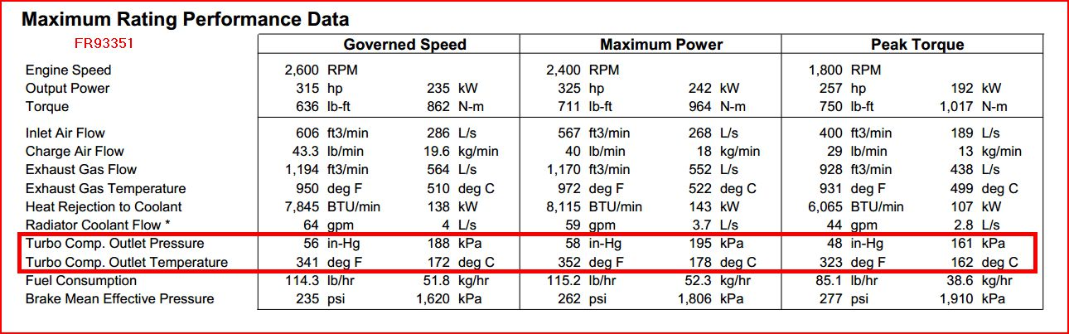

B: Material Properties of Aluminum 356

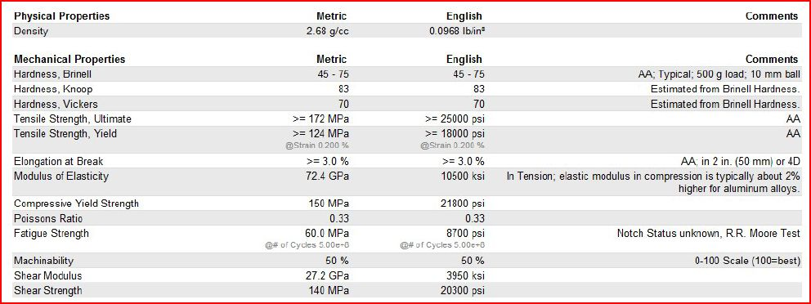

C: Previous FEA Results
C-1 TECAPEEK Total Displacement
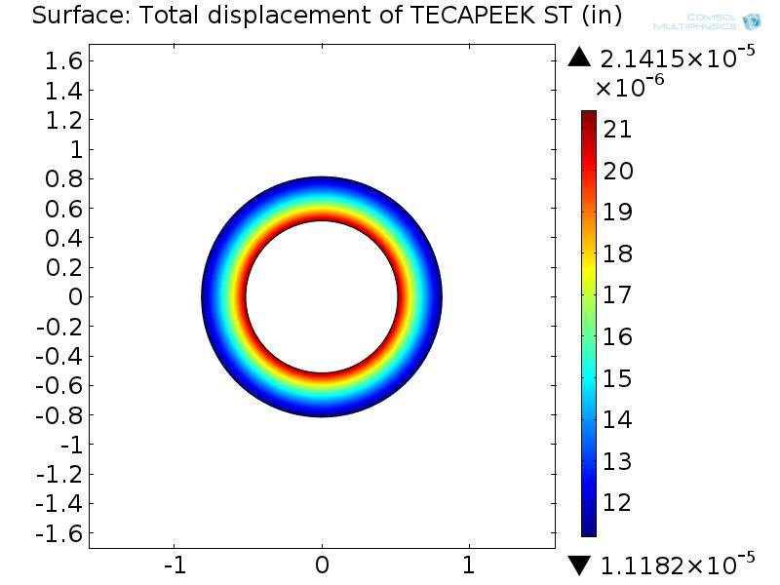

C-2 PEEK Unfilled Total Displacement
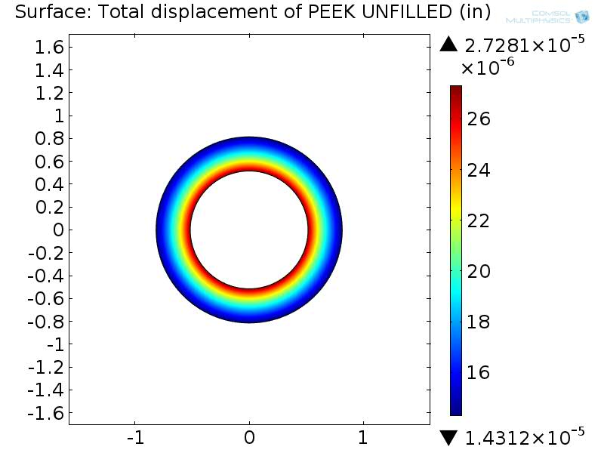

C-3 EXTEM XH Total Displacement

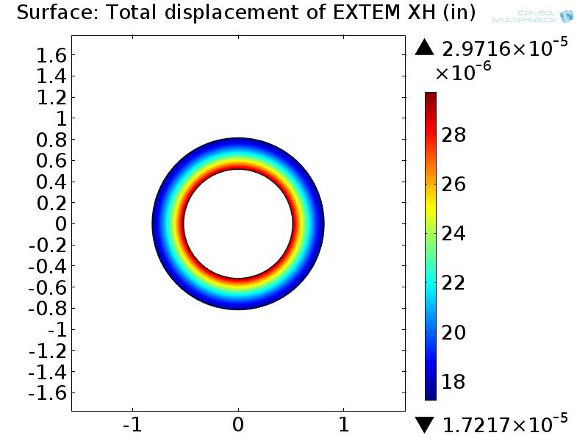

C-4 TECATOR T15013 Total Displacement
